Price List 2015

Sport Shooting Club

R1 200.00 annual membership fee.
Club shoots are arranged monthly, every third Saturday.
The clubhouse facility is available to members.
Members are eligible for reduced accommodation tariffs as per the price list.

Shooting Range

100 metre open air rifle range – 3 metre to 25 metre pistol range.

Occasional use of range by non-members | R200.00
Occasional use of range by non-member accompanied by a club member | R100.00
Non-member group rate: exclusive day use of range by non-members. Openings available Monday – Friday only by prior arrangement. Groups limited to a maximum of 10 persons. | R1 000.00
Club member group rate – in addition to free visits allowed by club membership | Price on Request
Clay pigeon shooting | Price on Request

Firearm Competency Training
Solidus Security Services (Pty) Ltd trading as Windy Pines Shooting Range

20% rebate on all firearms competency training applies to club members.

Category 1:
Category 1 is currently required for the renewal of existing license holders who have already completed the unit standards applicable to the firearms in respect of which they are applying for renewal and will become the entry level that is assumed to be in place for all other firearm Unit Standards (Unit Standard – US). This category is also the entry level for Category 2.

Course Name | Price
Knowledge of the Firearms Control Act, 2000 (Act No. 60 of 2000) US 117705 | R450.00

Category 2:
Category 2 is the requirement for all first time firearm ownership or for the renewal of competency for those firearm owners who changed from the old Green Firearm Licence to the new card system by only completing the Knowledge competency without doing the other unit standards.
These Unit Standards are the equivalent of what is known internationally as BASIC LEVEL. This category is also the entry level for Category 3.

Course Name | Excluding Firearm and Ammunition | Including Ammunition and Use of Company Firearms
Handle and Use a Handgun US 119649 | R850.00 | R1 000.00
Handle and use a Shotgun US 119652 | R850.00 | R1 000.00
Handle and use a manually operated Rifle or Carbine US 119651 | R850.00 | R1 000.00
Handle and use a self-loading Rifle or Carbine US 119650 | R850.00 | R1 000.00

Category 3:
Category 3 is applicable to security guards and anybody else who is to be issued with a company firearm – for example a Game Scout or Ranger. This category is for firearms licensed to a company or institution for “business purposes”. This means for example that a security officer who needs to carry a business owned shotgun will be required to first complete the Knowledge US 117705 followed by the appropriate Basic US 119652 and subsequently the Business US 123514. This category is an INTERMEDIATE or duty related level which must be preceded by the Basic Unit Standards.

Course Name | Excluding Firearm and Ammunition | Including Firearm and Ammunition
Handle and use a Handgun for Business purposes US 123515 | R1 250.00 | R1 650.00
Handle and use a Shotgun for Business purposes US 123514 | R1 250.00 | R1 650.00
Handle and use a self-loading Rifle or Carbine for business purposes US 123511 | R1 250.00 | R1 650.00
Handle and use a manually operated Rifle or Carbine for business purposes US 123519 | R1 250.00 | R1 650.00

Category 2 for more than 1 Unit Standard – Inclusive of Firearms and Ammunition

Legal and 1 Basic Unit Standard (e.g. Handgun) | R1 500.00
Legal and 2 Basic Unit Standards(e.g. Handgun and Shotgun) | R2 100.00
Legal and 3 Basic Unit Standards (e.g. Handgun Shotgun and Manually Operated Rifle) | R2 750. 00
Legal and 4 Basic Unit Standards (Handgun, Shotgun, Manually Operated Rifle and Self-Loading rifle ) | R3 400. 00

Above prices for the basic combination training include ammunition – basic level 50 rounds for handgun, 20 rounds for rifle and 20 rounds for shotgun.
Should additional ammunition be required this should be purchased separately.

Business Purposes for more than 1 Unit Standard – Inclusive of Firearms and Ammunition

Legal and 1 Combination Private and Business Purposes Unit Standards (e.g. Handgun) | R2 250.00
Legal and 2 Combination Private and Business Purposes Unit Standards (e.g. Handgun and Shotgun) | R3 200.00
Legal and 3 Combination Unit Standards (e.g. Handgun, Shotgun and Self Loading Rifle) | R4 150.00
Legal and 4 Combination Private and Business Purposes Unit Standards (Handgun, Shotgun, Self Loading Rifle and Manually Operated Rifle) | R5 100.00

Business purposes include ammunition and firearm use, 100 rounds for handgun, 20 rounds for rifle, 20 rounds for shotgun.
Should additional ammunition be required this should be purchased separately.

Category 4:
Tactical Training Unit Standards
Category 4 is intended for all persons who would need to use a firearm in a tactical environment. This category is at an ADVANCED LEVEL.
Price on request, please phone our offices on 014-5762281 or email shotandball@gmail.com.

We are registered to offer the following unit standards:

Course Name | Unit Standard
Supervise the operation of a shooting range and tactical shooting exercises | US 123517
Apply tactical knowledge in the use of firearms | US 123510
Demonstrate tactical proficiency with a handgun | US 123513
Demonstrate tactical proficiency with a rifle | US 123518
Demonstrate tactical proficiency with a shotgun | US 123512

Regulation 21
Prices range from R350.00 to R550.00 depending on the client requirements excluding ammunition.
Please phone our offices on 014-576 2291 or email shotandball@gmail.com to discuss your needs.

Accommodation and Functions

Accommodation
Self-catering accommodation is available to our guests. Club members will enjoy preference in respect of bookings.
Prices quoted below are available to club members only.
To our non-club members – join the club! If you would like to test drive our facilities before you take the final decision to become a member, please call our office at 014 576 2281 or email us at shotandball@gmail.com for non-club room rates.

For Members Who Like to Rough it
A six sleeper tent with bathroom.
Single beds are available, bring your own sleeping bag and towels.
Minimum two night stay, R150.00 per person per night.
Braai facilities are available.

For Couples that Prefer More Luxury and Privacy
Luxury Room
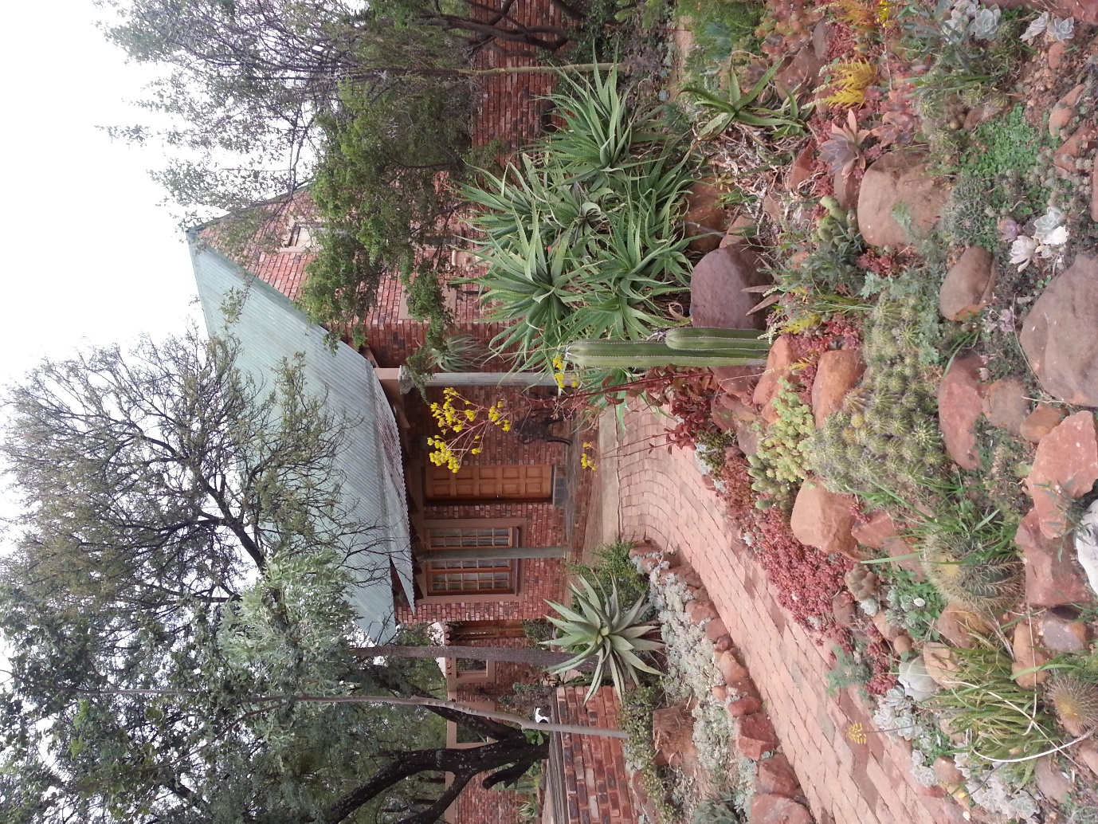

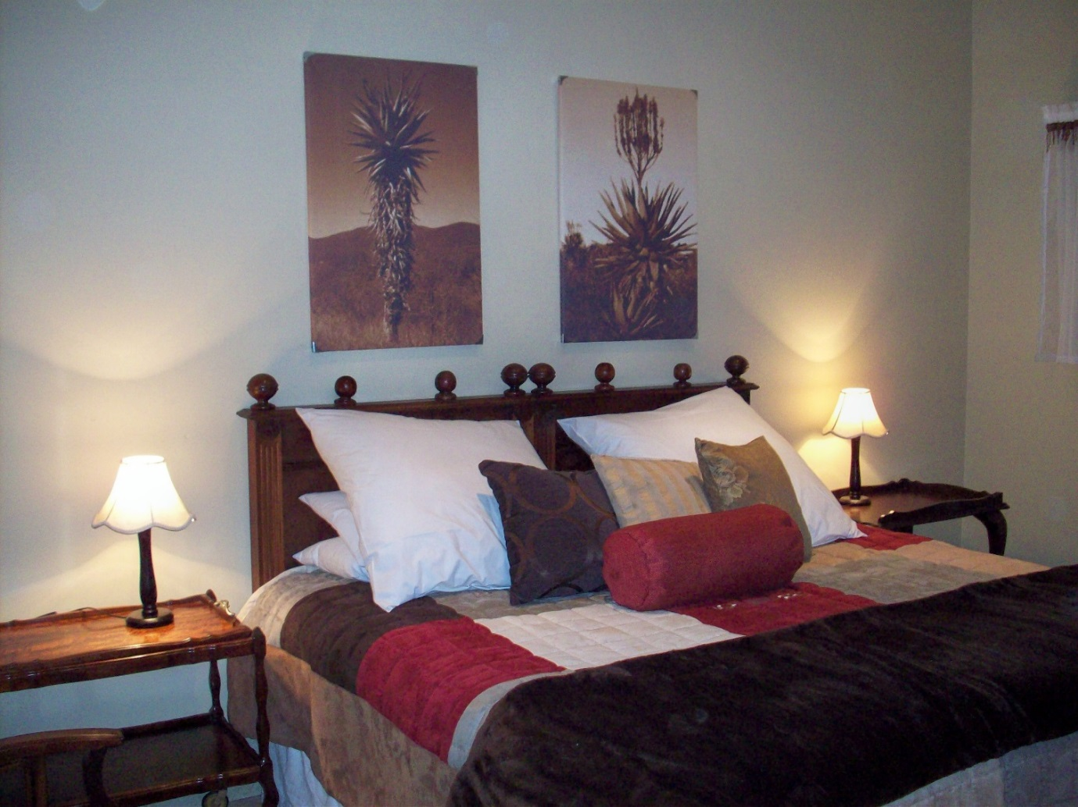
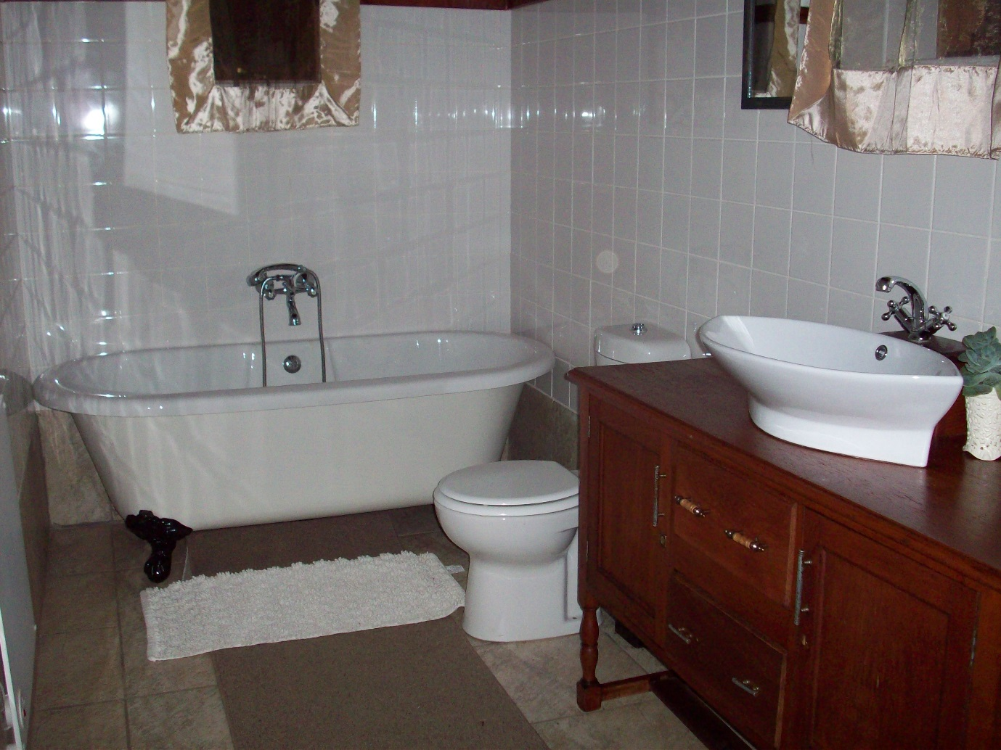
1 Luxury en suite room with king size bed.
Linen and towels provided.
Minimum two night stay.
Weekend Rate: R350.00 per person sharing per night.
Mid-week Rate: R300.00 per person sharing per night.

Two-Bedroom Cottage
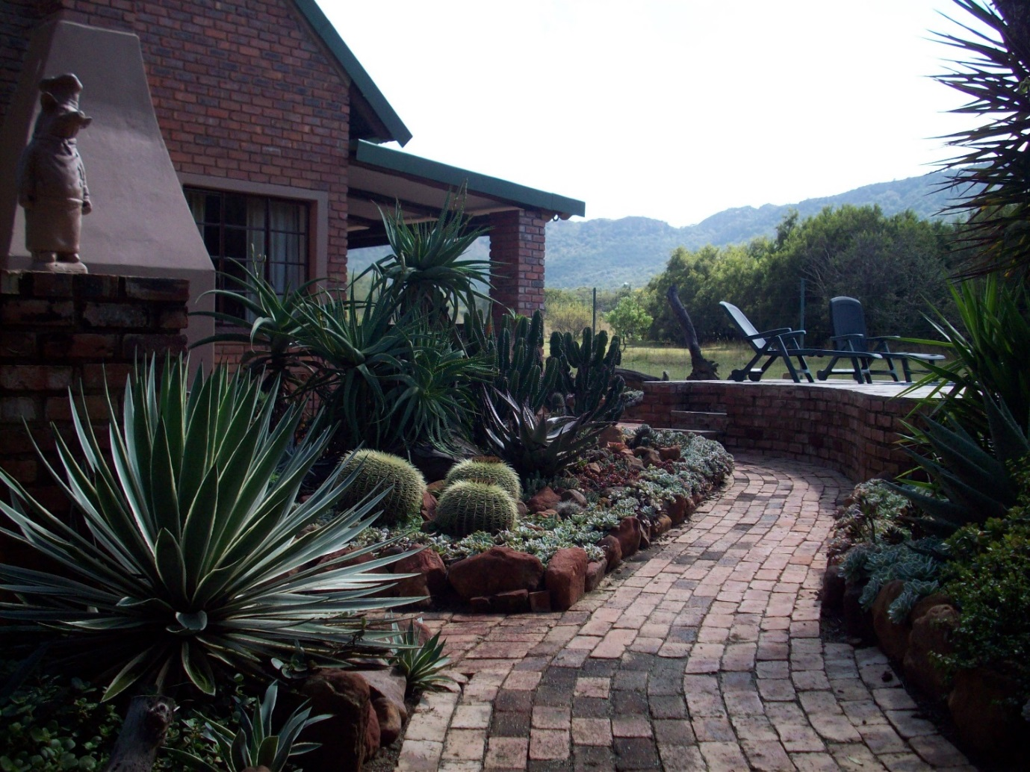
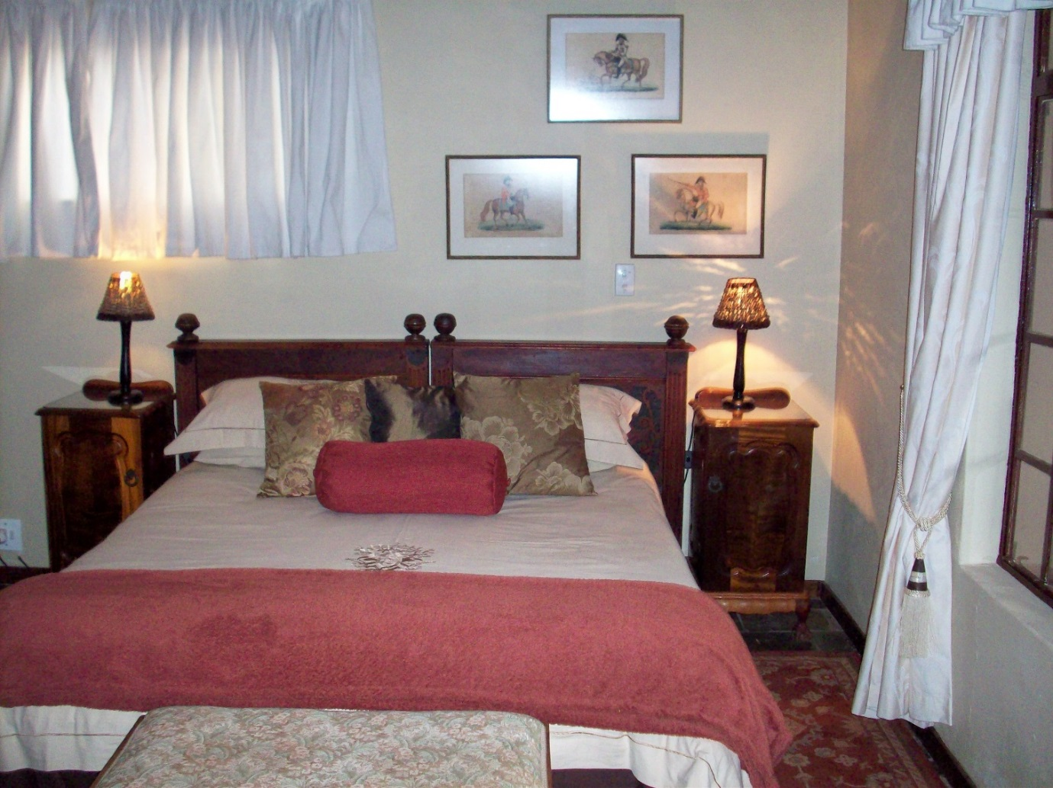
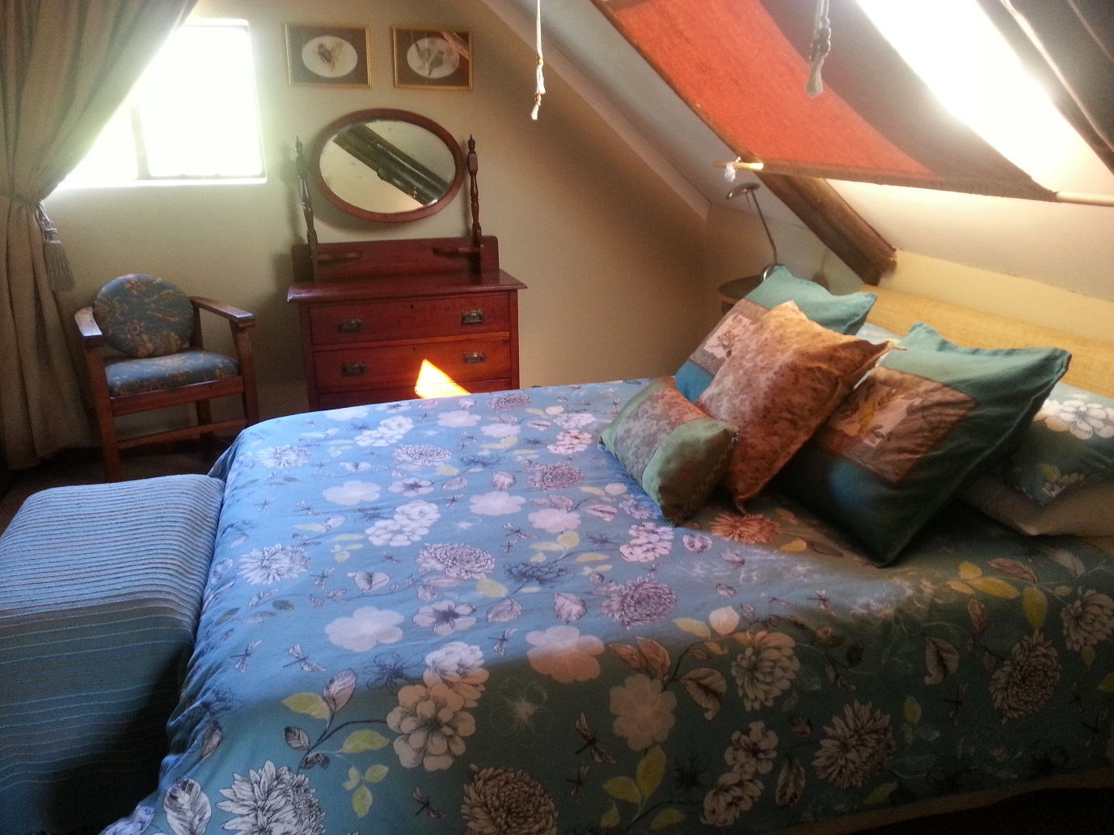
Two bedrooms with queen size beds both en-suite.
I room on ground floor with shower and 1 loft room with bath.
Linen and towels are provided.
Weekend Rate: R1200.00 for the entire cottage per night.
Mid-week Rate: R1000.00 for the entire cottage per night.

Additional accommodation in close proximity can be arranged if required by larger groups.

Meals can also be provided for those who do not wish to self-cater – please phone our office at 014 576 2281 or email us at shotandball@gmail.com to enquire.

Events

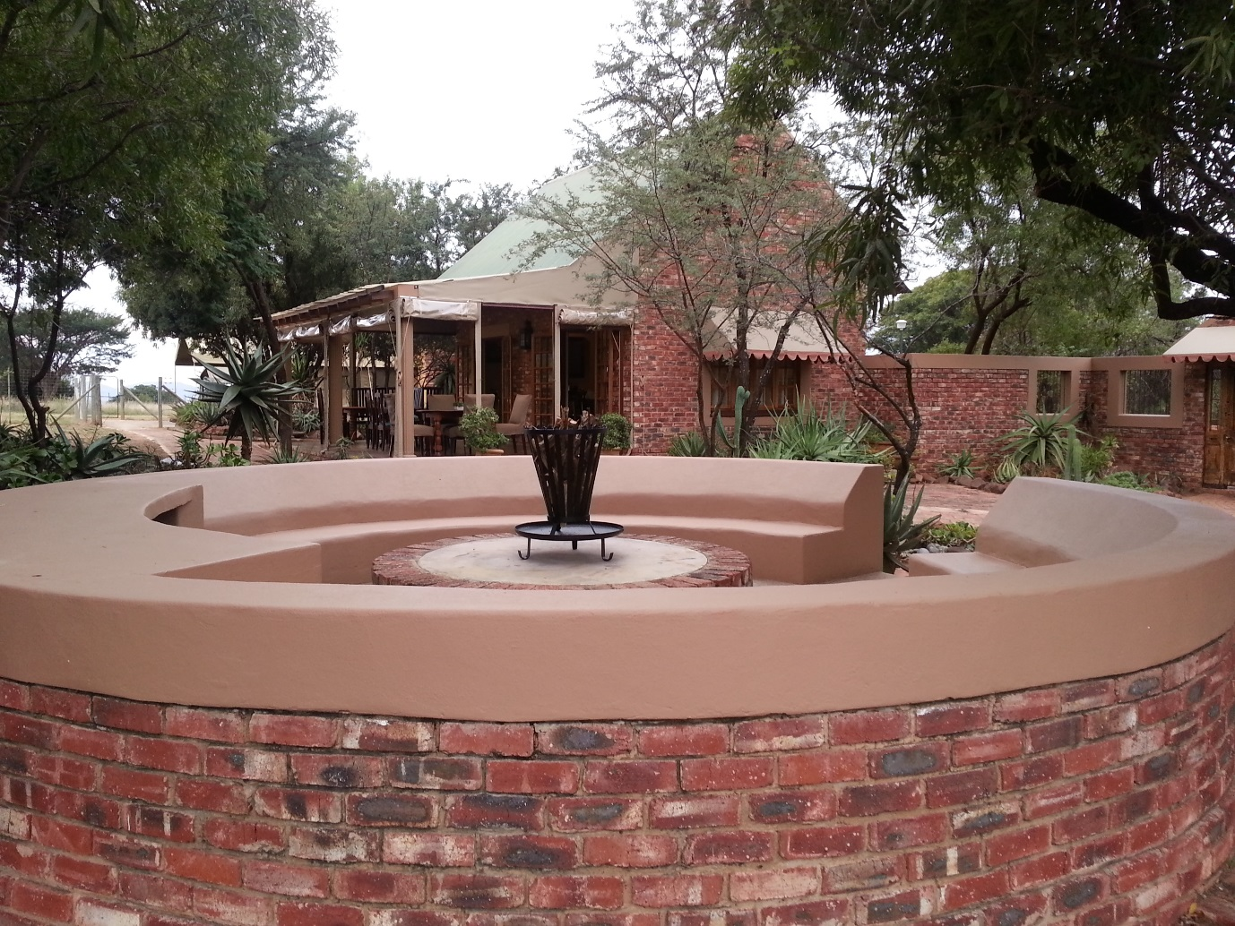
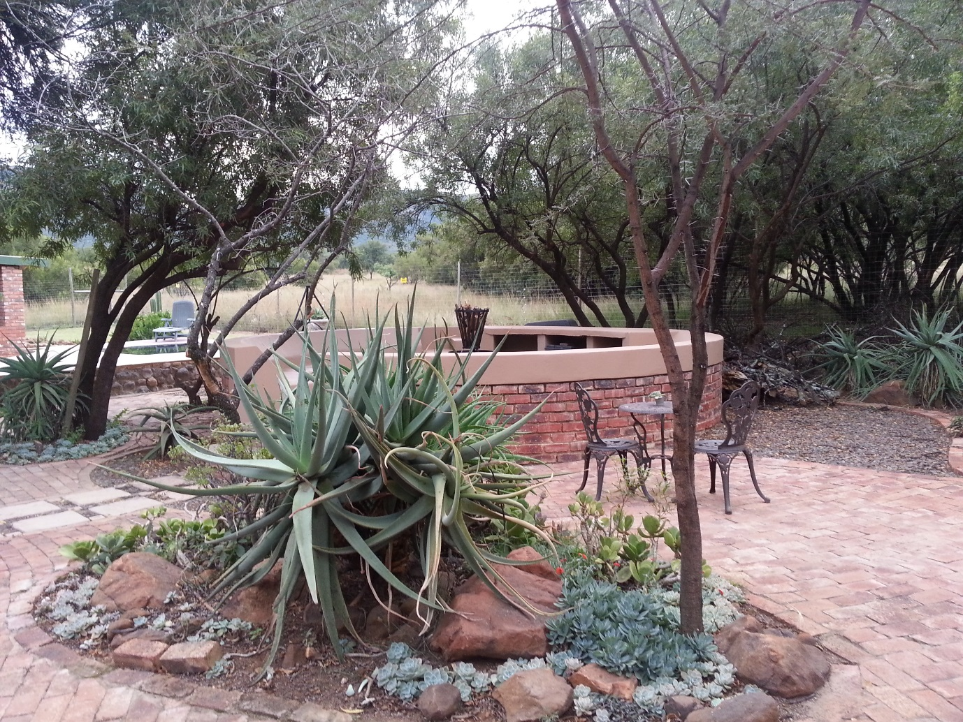

Designed to your specifications, please contact our office at 014 576 2281 or email us at shotandball@gmail.com to discuss your requirements.

